Requirement Analysis Document
Project Title: Loan Application Fraud & Defaulter Detection System

1. Introduction

1.1 Problem Statement
Financial institutions face significant risks due to fraudulent loan applications and undisclosed defaulters. Manual verification is time-consuming, error-prone and unable to detect sophisticated fraud patterns. There is a need for an automated system that integrates with external authority APIs (credit bureaus/fraud detection services) to identify high-risk applicants before loan disbursement.

1.2 Objectives
- Provide applicants with a digital loan application platform.
- Enable loan officers to review, verify and trigger fraud screening.
- Integrate with external authority APIs for fraud/defaulter checks.
- Provide compliance officers with flagged applications for deeper review.
- Automate notifications and escalation workflows for faster decision-making.

2. User Roles
- Applicant – Submits loan application, uploads documents, tracks status.
- Loan Officer – Reviews applications, triggers fraud screening, approves or forwards flagged cases.
- Compliance Officer – Handles flagged applications, reviews fraud history, gives final decision.
- External Authority API – Provides fraud/defaulter risk data (mocked in this project).

3. Functional Requirements

3.1 Applicant Module
- Apply for loan through an online form.
- Upload required documents (ID, income proof, etc.).
- Track loan application status (submitted, under review, approved, rejected).
- Receive notifications about application progress or flags.

3.2 Loan Officer Module
- View new loan applications in a table format.
- Track applications currently under review.
- View flagged applications from fraud screening.
- Trigger fraud/defaulter check by calling the external API.
- Approve applications or forward them to Compliance Officer.
- Receive email alerts when an application is flagged.

3.3 Compliance Officer Module
- View all flagged applications escalated from Loan Officers.
- Review fraud tags and past investigation history.
- Access applicant’s risk profile, fraud indicators, and API response.
- Approve or reject the application based on detailed risk analysis.
- Receive system-generated emails for escalated cases.

3.4 External Authority Integration
(Sample APIs)
- POST /api/defaulters/check → Input applicant identifiers, return fraud risk.
- GET /api/defaulters/by-pan/{pan} → Fetch fraud/defaulter history by PAN.
- GET /api/defaulters/by-aadhaar/{aadhaar} → Fetch fraud/defaulter history by Aadhaar.
- Response includes (Sample) :
{
"matched": true,
"risk_level": "high",
"fraud_tags": ["defaulter", "identity_mismatch"],
"remarks": "Applicant has prior loan default"
}

4. Non-Functional Requirements
- Performance: API response time under 3 seconds.
- Security: Data encryption (PAN, Aadhaar, documents).
- Scalability: Support multiple loan officers and compliance officers.
- Reliability: 99.9% system uptime.
- Usability: Simple dashboard interfaces for all user roles.

5. Workflow (Real-Time Flow)
- Applicant submits loan application → Uploads documents.
- Loan Officer reviews application → Can trigger fraud screening via API.
- System calls External API → Returns fraud tags and risk level.
  - If Clean → Loan Officer may approve.
  - If Flagged → Application escalated to Compliance Officer.
- Compliance Officer reviews flagged case → Looks at fraud tags, investigation history, and makes Final Decision.
- System sends email notifications to Applicant & Officers based on decision.
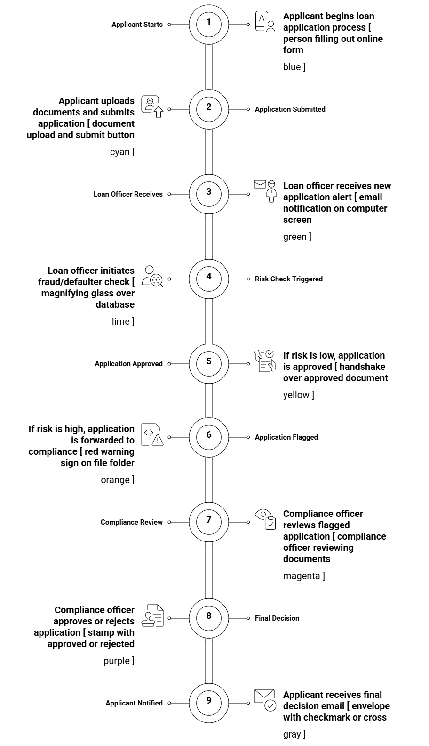

6. Wireframes (Reference)
- Applicant Dashboard: Apply for Loan, Upload Documents, Status Tracker, Notifications.
- Loan Officer Dashboard: New Applications, In Review, Flagged, Trigger Fraud Check.
- Compliance Officer Dashboard: Flagged Applications, Fraud Tags, Investigation History, Approve/Reject Panel.

7. Conclusion
The proposed system ensures faster loan processing with fraud detection integration. By involving Loan Officers, Compliance Officers and External APIs, the system reduces risks of financial loss and ensures regulatory compliance.

